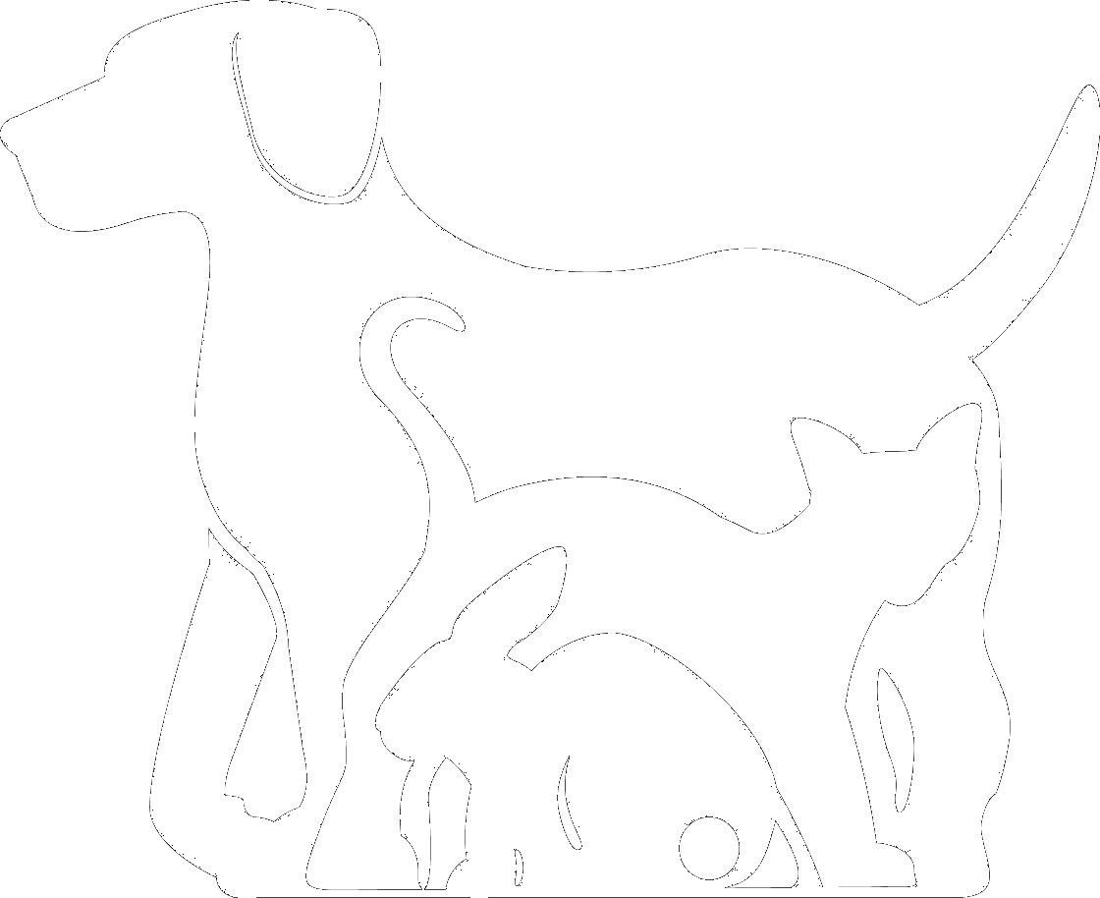
Camberwell Veterinary Clinic

896 Riversdale Road, Camberwell Vic 3124 Telephone 03 98360536 Fax 03 98884710

camberwellvet@hotmail.com
SG & Y Emms Pty Ltd A.C.N. 007 325 859
In association with


CT Imaging Request.
Practice details
Practice name
Referring vet
Telephone
Email address

Patient details
Owner name |  | Species
Patient name |  | Breed
Practice ID number |  | Sex |  | Age
Summary of history to inform radiologists.
Questions to be answered

 | CT Imaging Request
Body areas | Head | □ | Neck | □ | Thorax | □ | Abdomen/Pelvis | □ | Stifles | o
Body areas | Spine C1-T2 | □ | Spine T3-sacrum | □ | Shoulders | □ | Elbows | □ | Other | o

Imaging safety questionnaire
Does the patient have any of the following? If so, please provide details
Heart disease/ Pacemaker | Y | N
Renal disease | Y | N
Known adverse reactions to medications | Y | N
Surgery within the previous two months | Y | N
Metal fragments / implants any location | Y | N
Pregnancy | Y | N
Endocrine disease, bleeding disorder, neoplasia | Y | N
Epilepsy | Y | N
NOTE: By submitting this form you confirm that you are a registered veterinary surgeon who has obtained consent from the patient’s owner to act on behalf of the animal described above; that the owner has given permission for the administration of an anaesthetic to the above animal at the imaging location together with any other procedures that may prove necessary; and that the owner understands that in the unlikely event of an emergency or where additional pain relief or sedation may be required, the Camberwell Veterinary Clinic will act in the best interests of the patient.; that the owner has agreed that they have understood that medicines may be used which are not licensed for use in dogs and cats; and that in the event that you cannot be contacted on the above number, you understand that the Camberwell Veterinary Clinic will act in the best interests of the patient.

